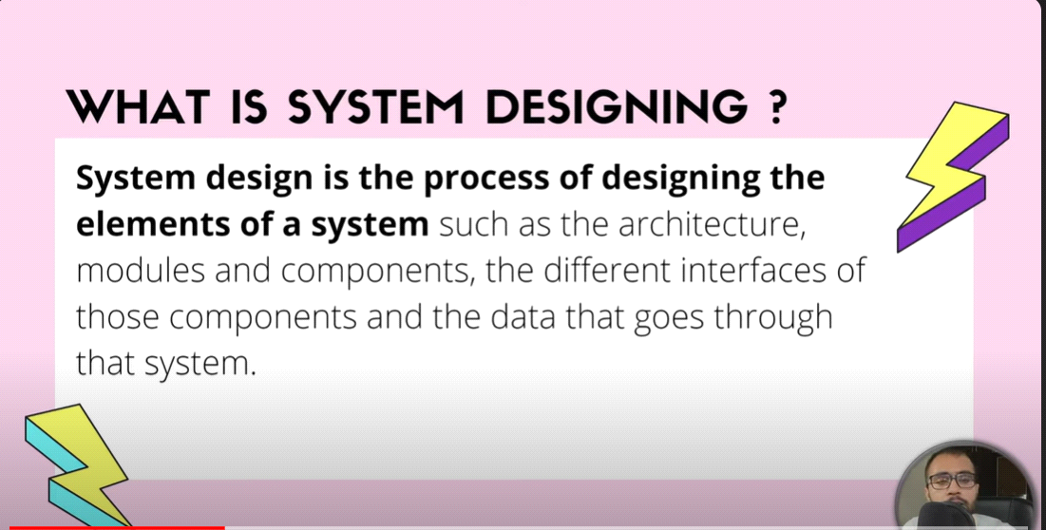

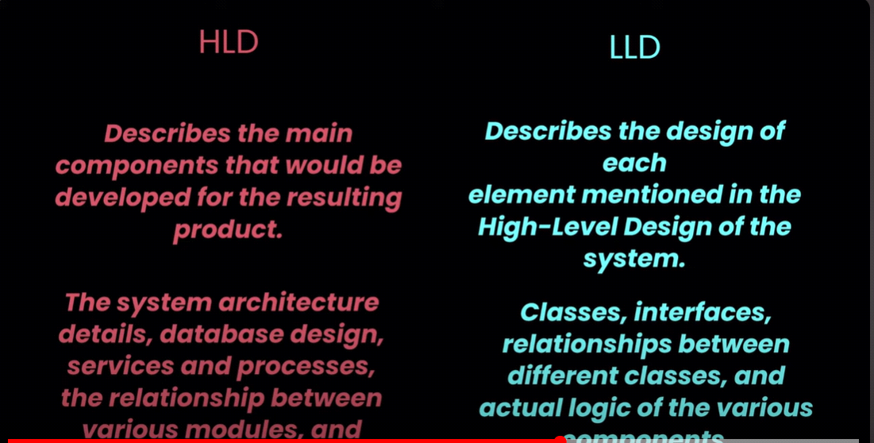

**Monolithic Architecture**

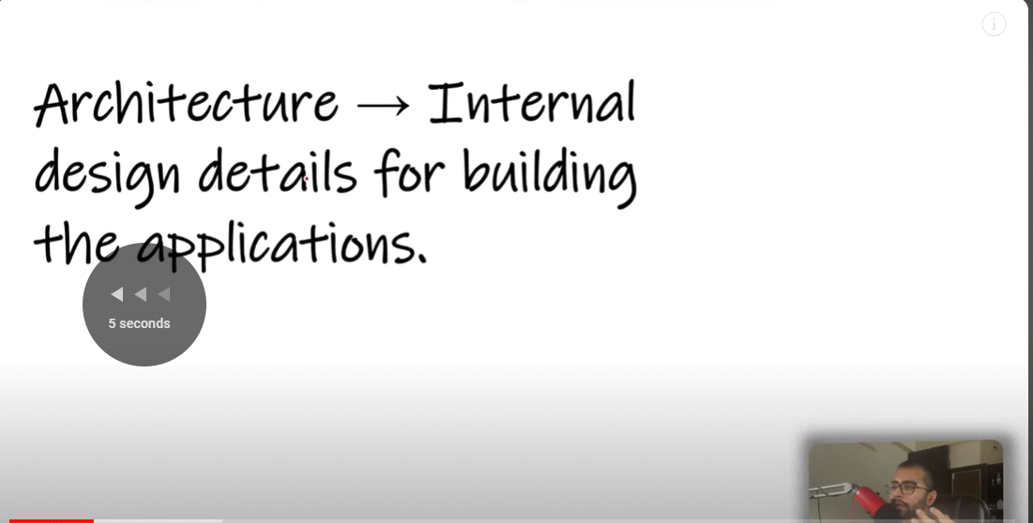

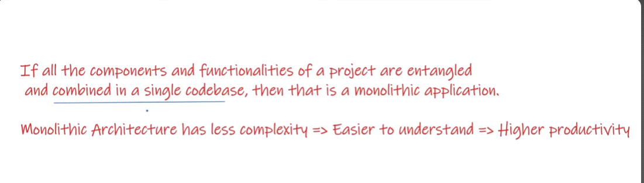

Monolithic Architecture is also know as centralized system.

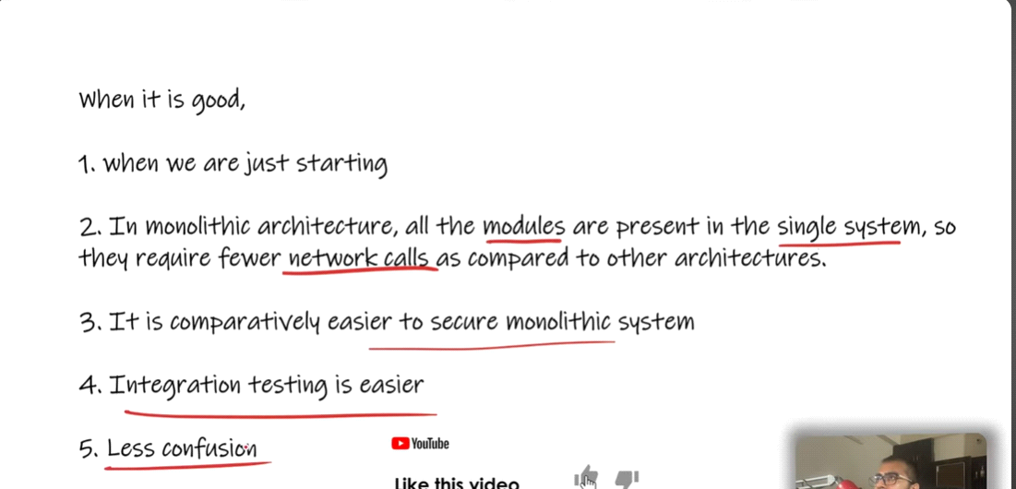

* Single point failure
* Not Scalable

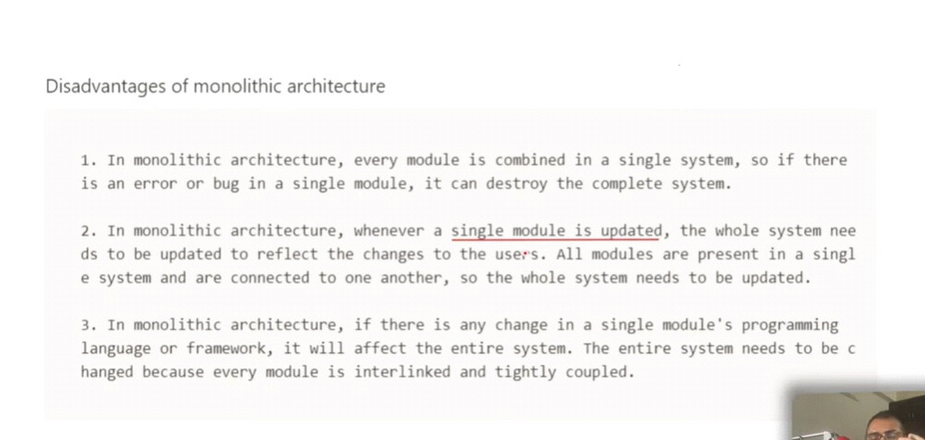

**Microservices architecture**

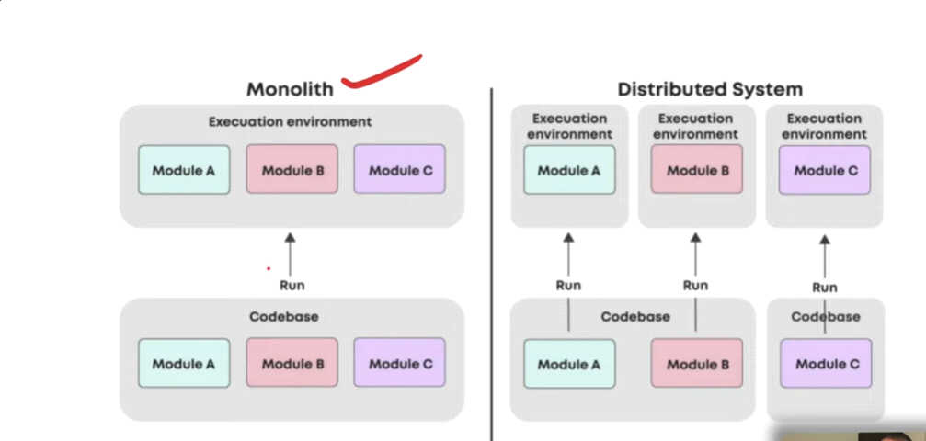

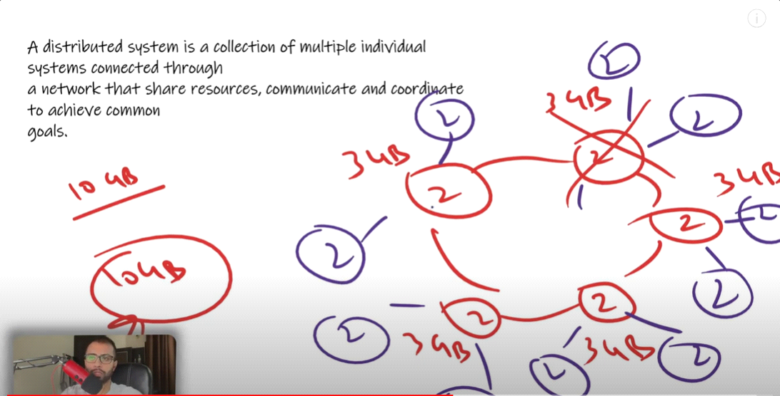

**Advantages:-**

* **Scalable :- system can be scalable in horizontally so if there one job was done by one machine then may be 2 machines distributes the job in half-half.**
* **SPOF:- Achieve the solution of single point of failure.**
* **Low latency**

**Disadvantages:-**

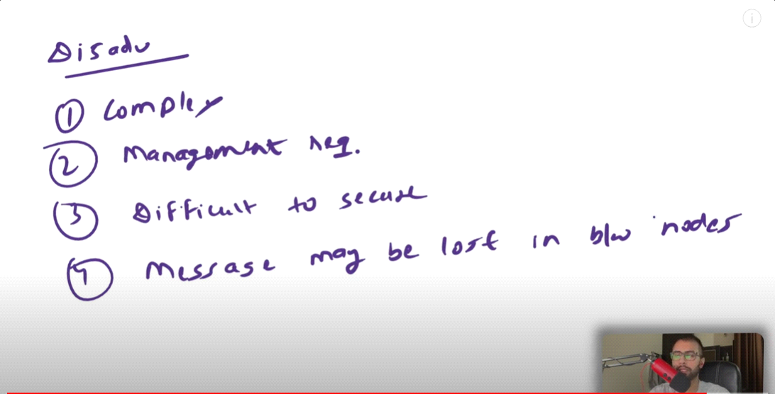

**Latency**

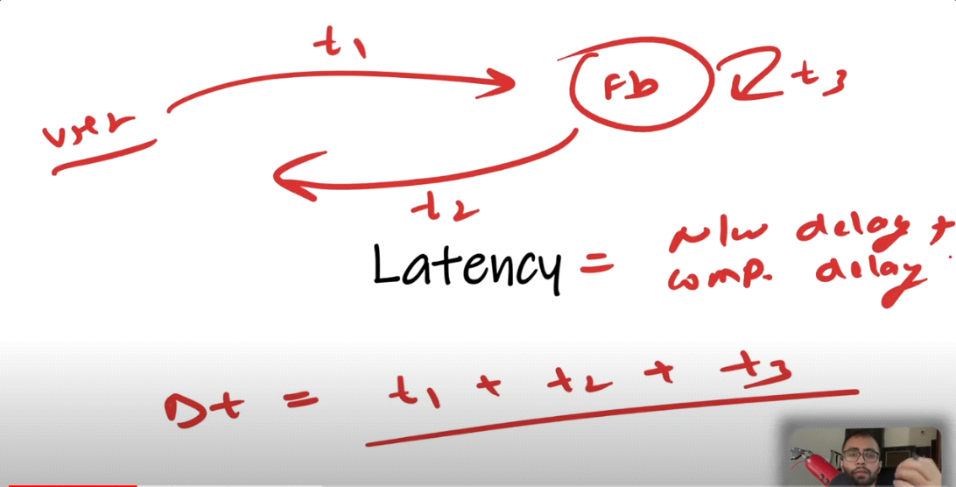

**Latency = Network Delay + Computational Delay**

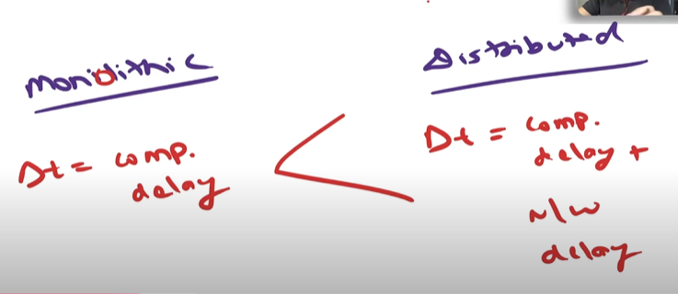

**Reduce Latency**

**-> Caching**

**-> CDN (Content Delivery Network)**

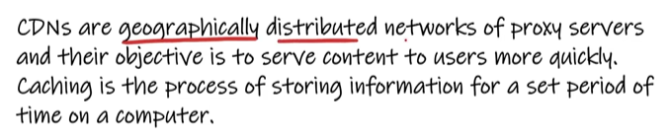

**-> Upgrade System**

**Throughput**

**The volume of work or infromation flowing through a system.**

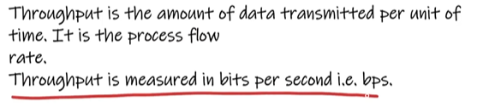

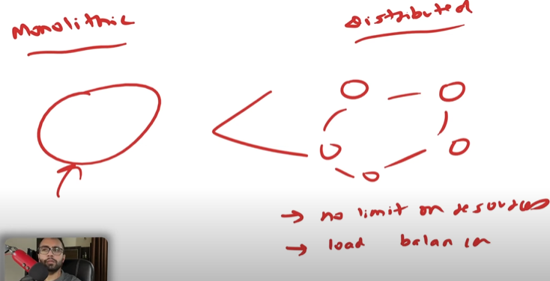

**Causes of Low Throughtput**

**-> Latency**

**-> protocol overhead**

**-> Congestion  
  
Improving Throughput**

**-> CDN  
-> Caching**

**-> DS**

**-> Load Balacer  
-> Improve Resources**

**Availability**

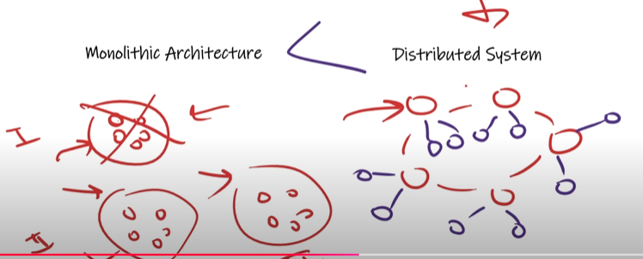

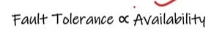

**How to increase the abailability**

**->Replication**

**-> DS**

**--> Redundancy**

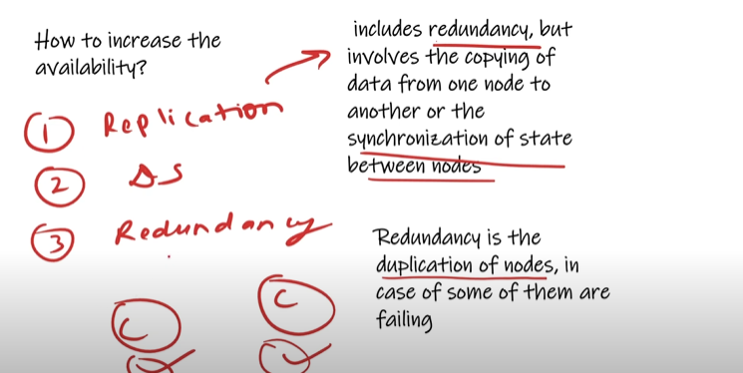

**Consistency**



**Usually Monolithik System is More consistant than Microlitjik beause in monolithic all structure and database available on one server**

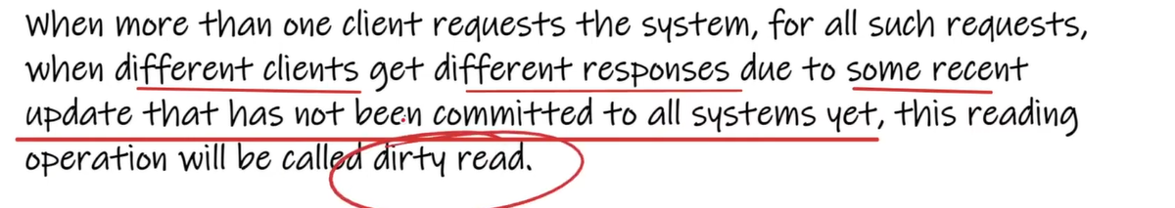

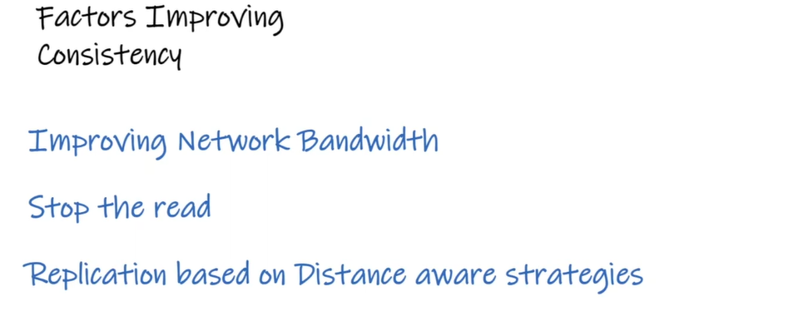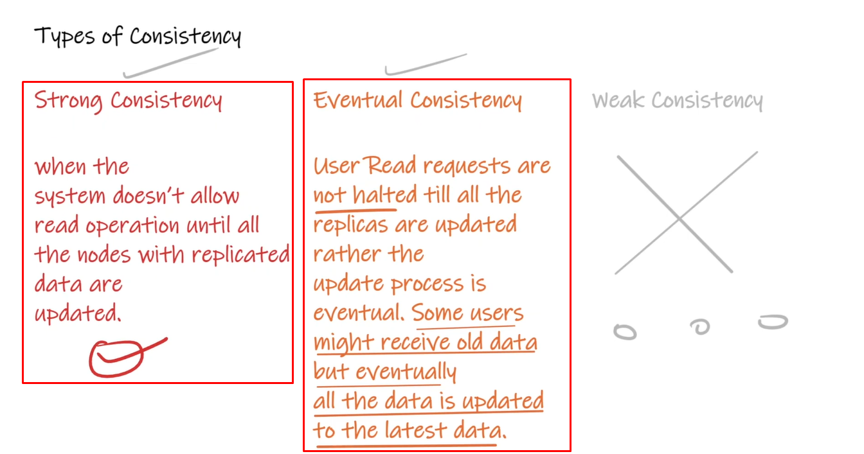

**CAP Theorem**

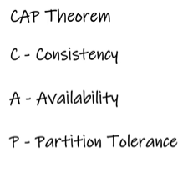 **Consistency - > Synchronized**

**Availability -> High fault Tolerance**

**Partition Tolerance -> made up with two words Partition ( In Distributed System or microlithic architecture application is divided in components and deployed on different server but when we any server goes down it is called Network Partitining) Tolerance ( It basically means we have to make less chances of failur)**

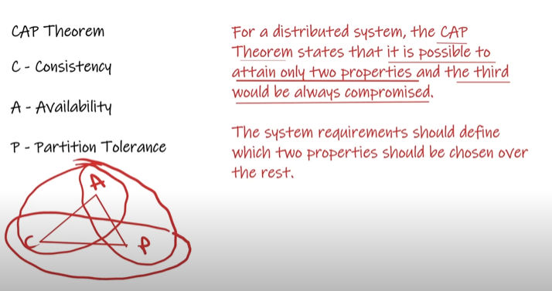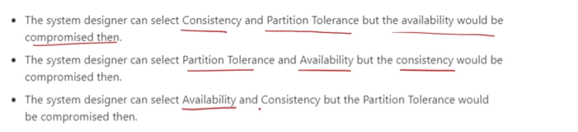

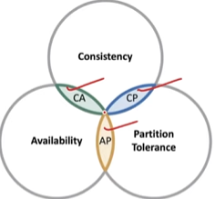

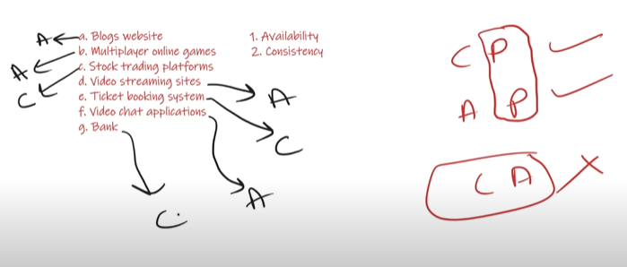

**Scalability**

1. **Vartical Scaling : In one machine increase only hardware specification.**

***Pros :***

**Easy implementation**

**Less power in mentaince**

**Management is easy**

***Cons:***

**SPOF**

**Limit**

**price**

1. **Horizontal Scaling: We increase By same machine acc. To need**

**Pros:**

**Reduces SPOF**

**No limit**

**Price is low comparing with vertical scaling**

**Cons:**

**Power Consumption is more**

**Implementation is tough**

**Management is difficult**

**Difference between Redundancy and Replication**

**Redundancy**

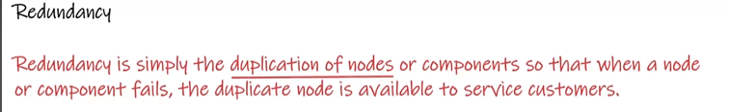

**Types Of Redundancy**

**1.**



**2.**



**Replication**



**At same time data should be same on all the severs**

**Basically Replication use in database**

1. **Active replication is a computing technique that processes the same request at every replica. In an active replication environment, nodes can replicate data to other nodes in a cluster. This allows all nodes to handle read and write operations simultaneously, unlike traditional master-slave configurations.**
2. **Passive replication**

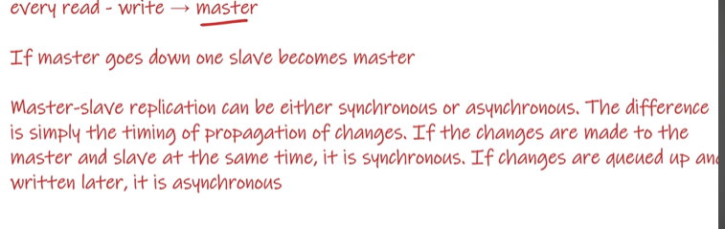

**load balancer**



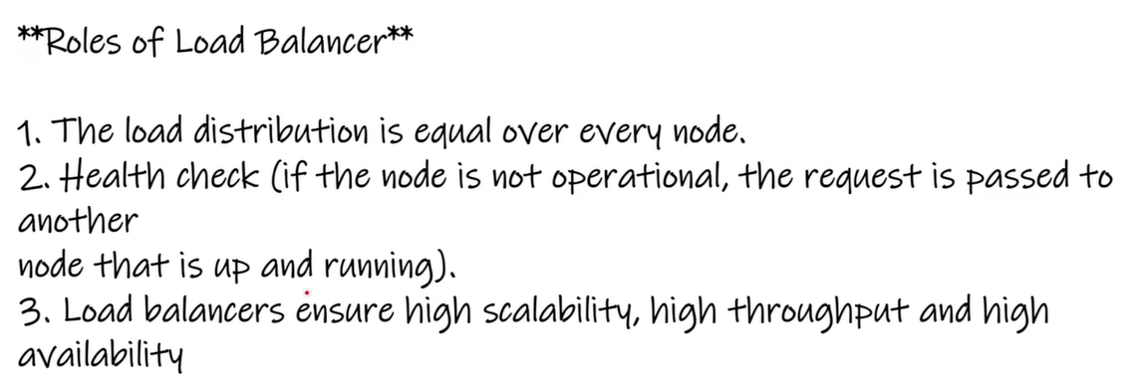



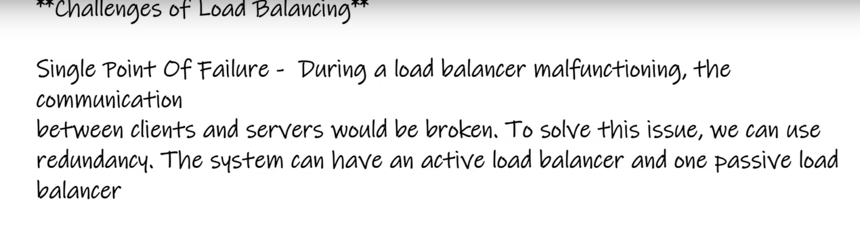

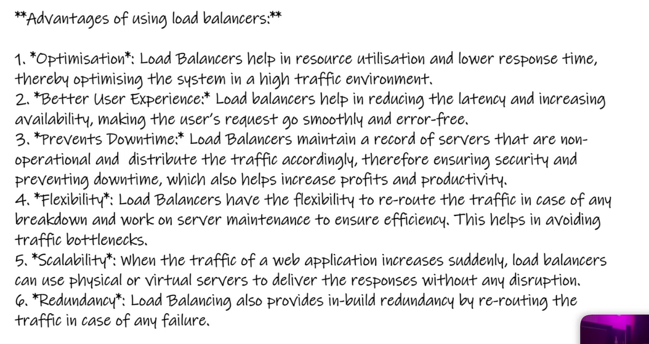

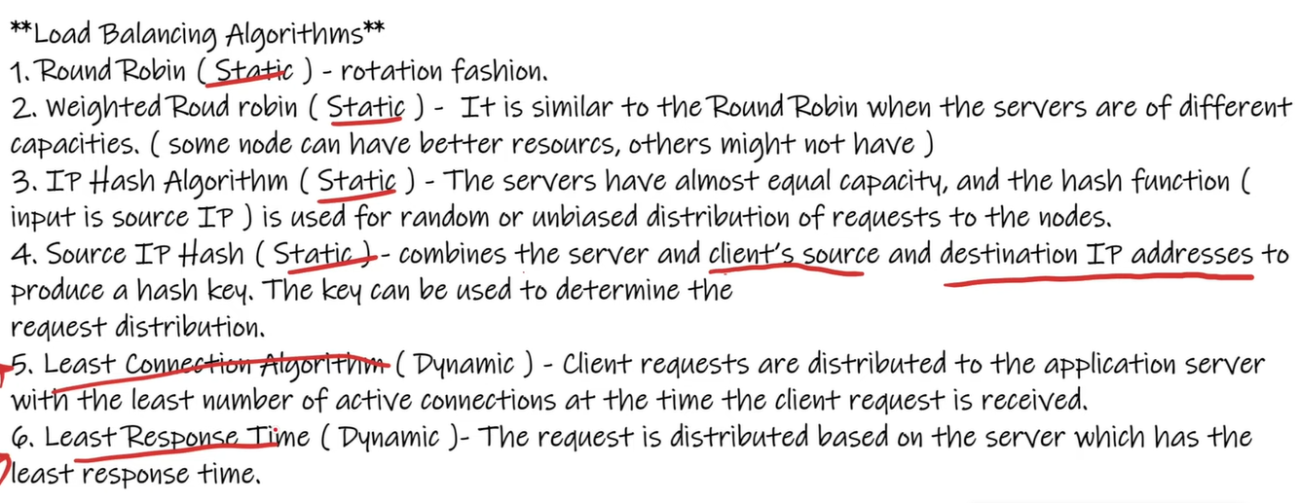

**Caching**

**Caching is a technique that stores data in a cache, a hardware or software component, to make it available faster when requested again. Caching can improve a system's performance and scalability by making data more accessible**

**Read Some More From Google**

**File based storage system**

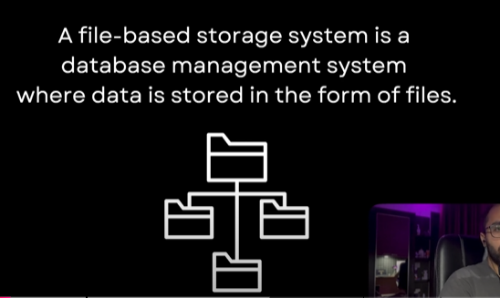

**RDBMS**

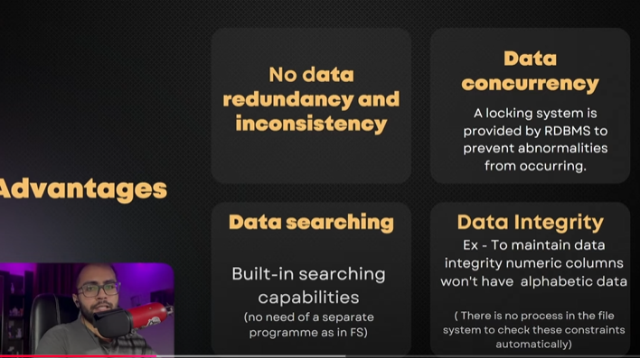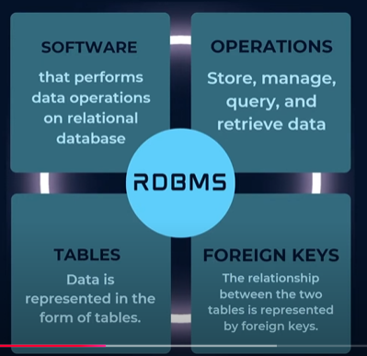

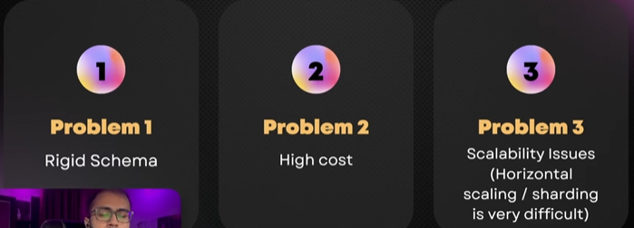

**NoSQL Databases**



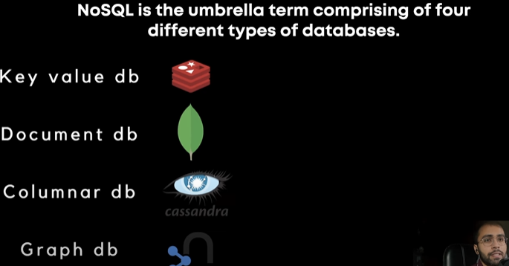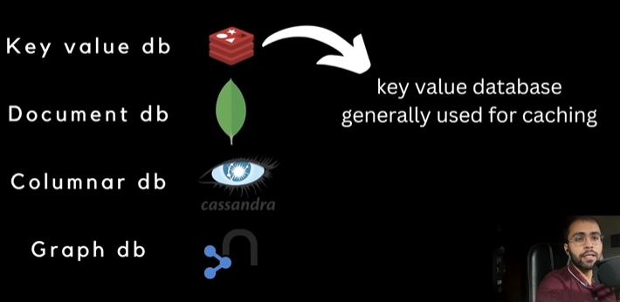

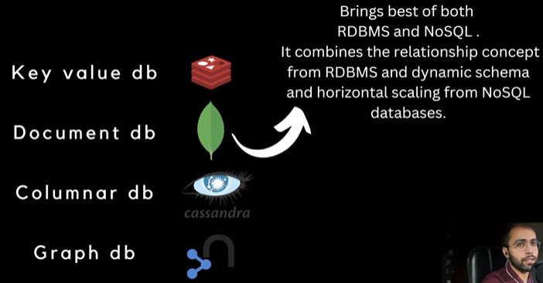

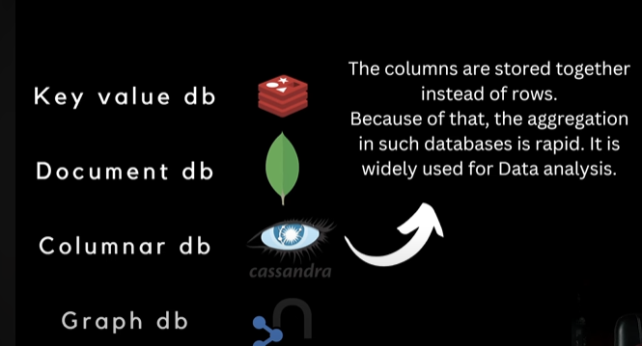

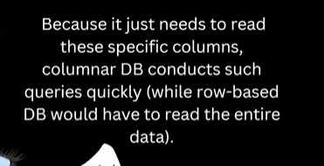

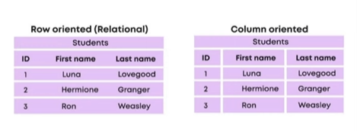

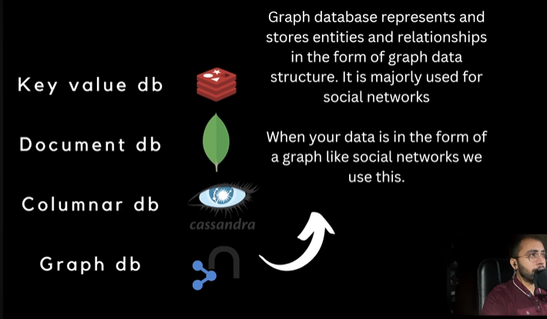

**Polyglot Persistence**

**when one data base is not enough for our application and we implement multiple database in one pplication then it is know as Polyglot Persistence.**

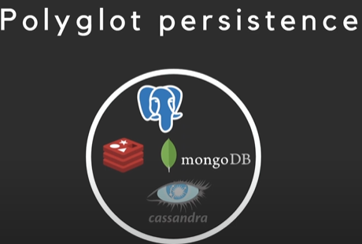

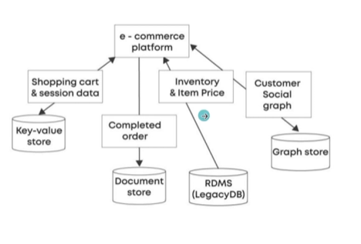

**What is denormalization in RDBMS**

**Normalization**

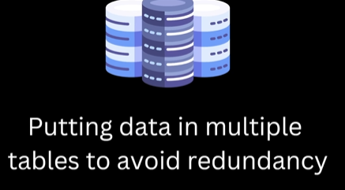 **Denormalization**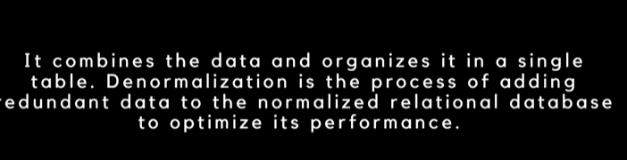

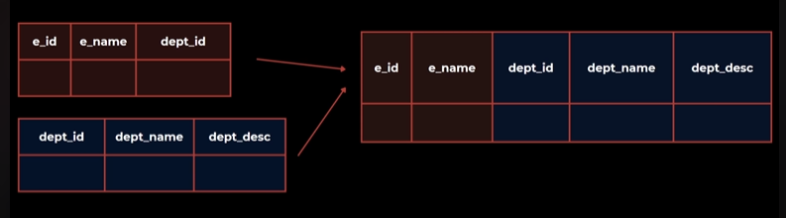

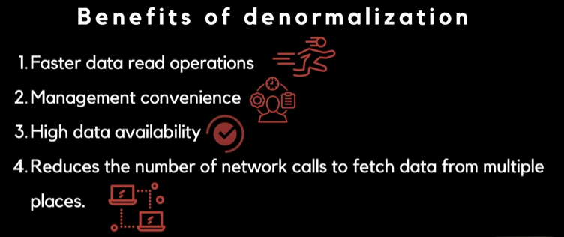

**indexing**



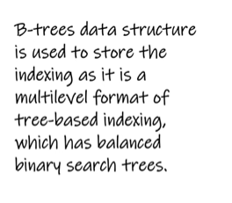

**Synchronous communication**

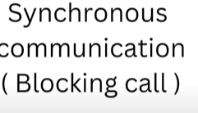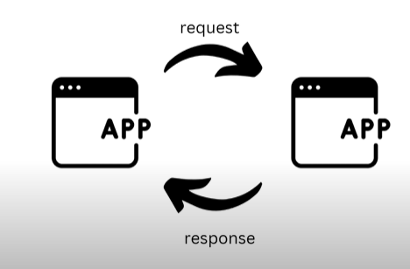

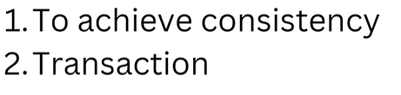

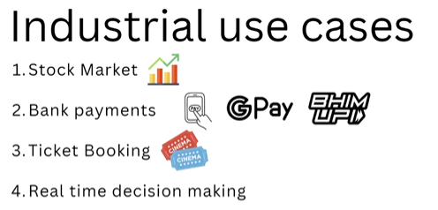

**asynchronous**

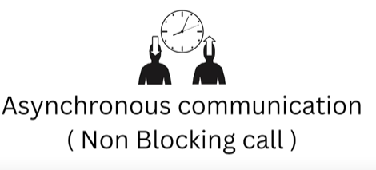







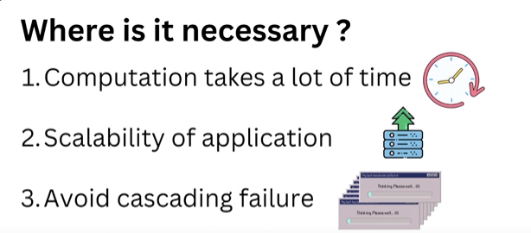

**message based communication**

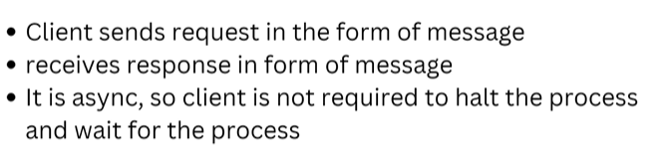

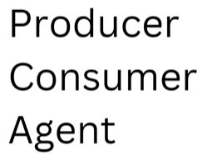

**P2P Model -> Peer to Peer Model**

**Public Subscribe Model**

**web server**

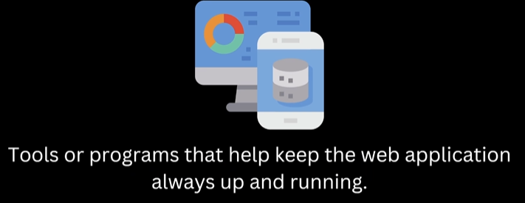

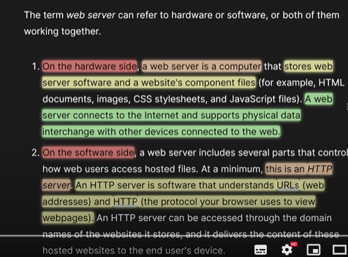

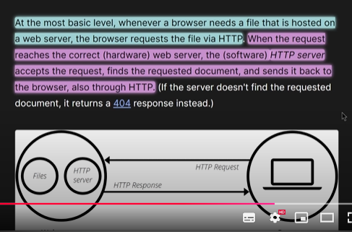

**communication protocol**

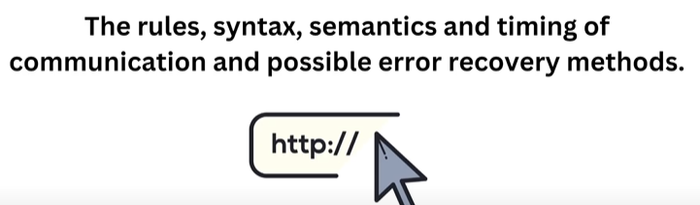

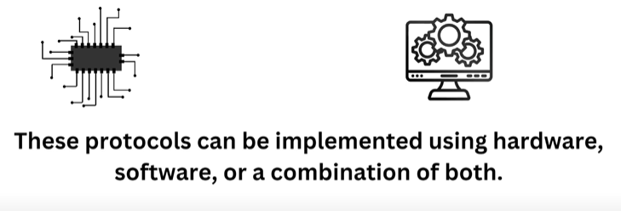

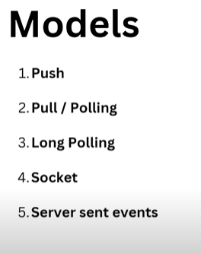

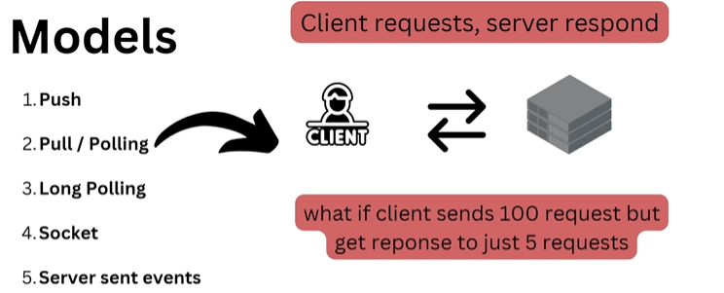

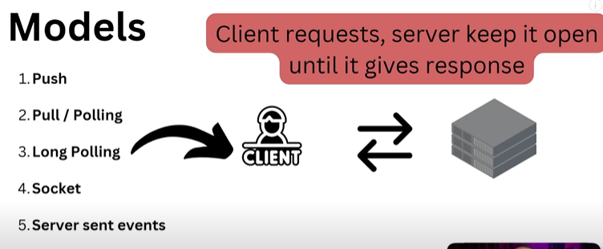

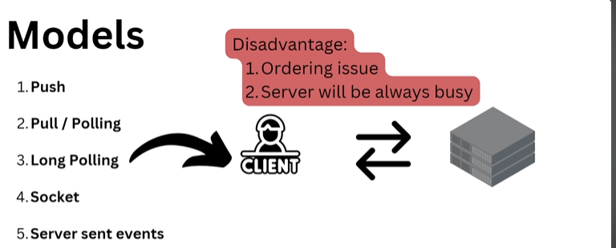

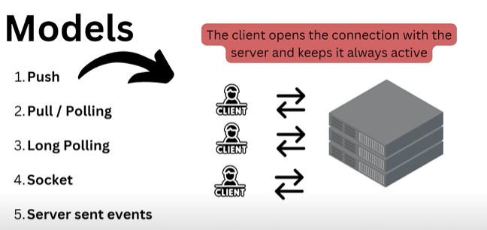

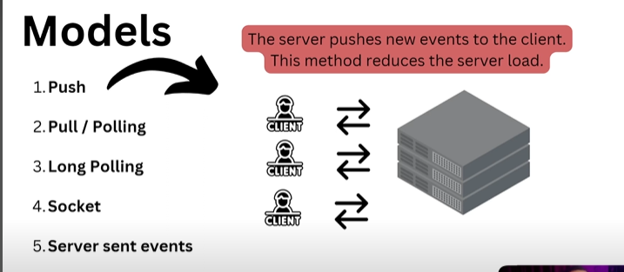

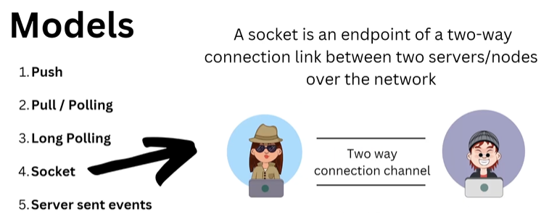

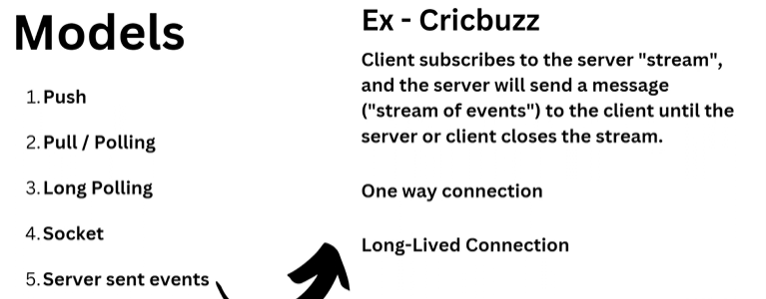

**Microservices architecture**

**Web App : Intractive’**

**Web Site : Static**

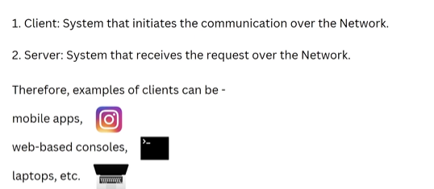



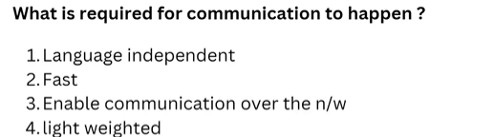

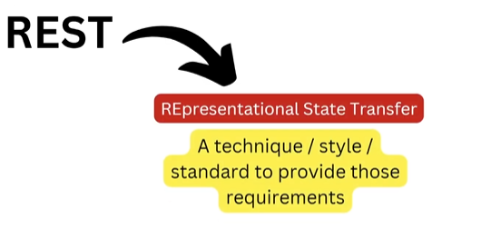

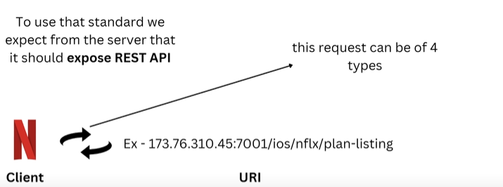



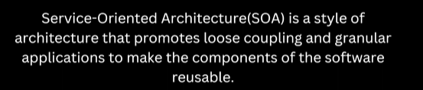

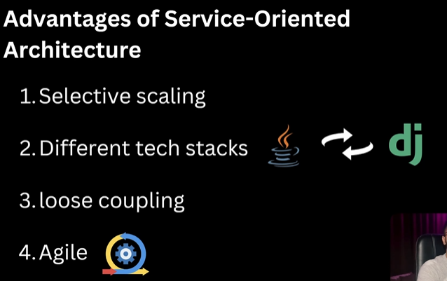

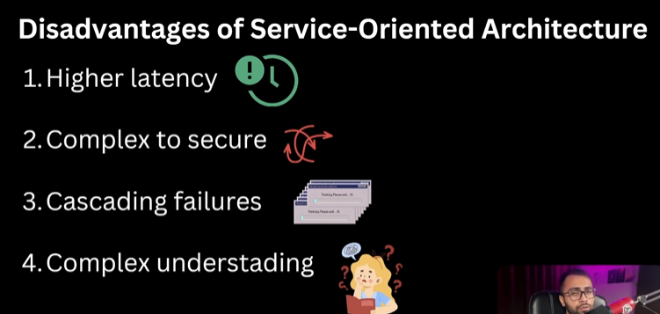



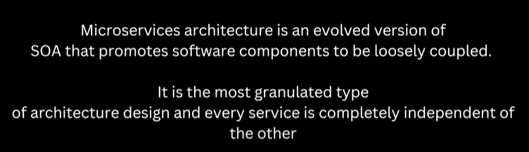

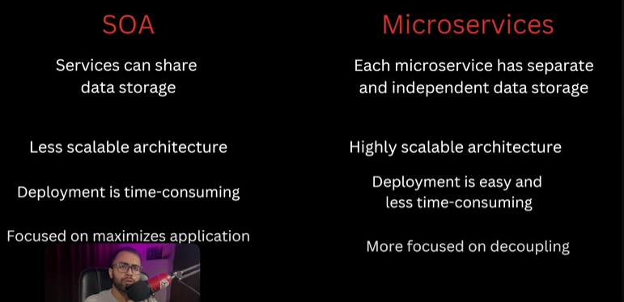







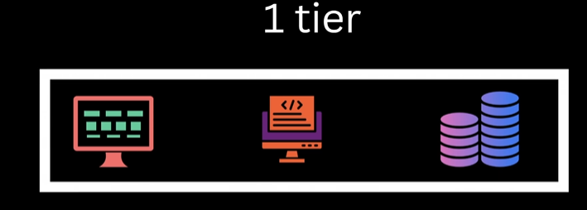

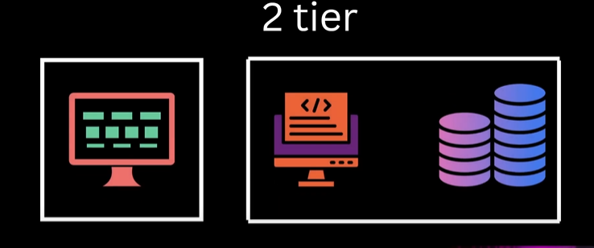

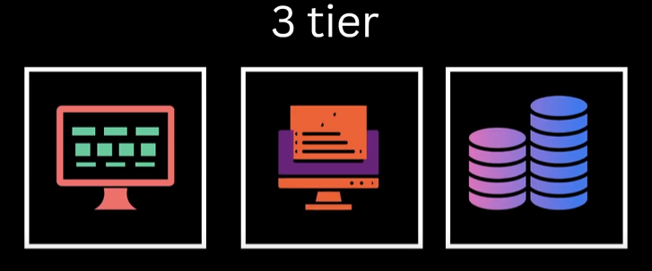

**Authentication and Authorization**

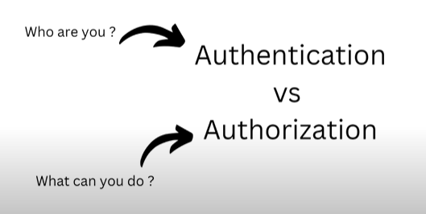

**Forward proxy and reverse proxy**

